1. Create Employee table with same structure as EMP table.

SQL>Create table employee as select * from emp where 1=3

SQL>desc employee

|  |  |  |
| --- | --- | --- |
| **Name** | **Null?** | **Type** |
| EMPNO | NOT NULL | NUMBER(4) |
| ENAME |  | VARCHAR2(10) |
| JOB |  | VARCHAR2(50) |
| MGR |  | NUMBER(4) |
| HIREDATE |  | DATE |
| SAL |  | NUMBER(7,2) |
| COMM |  | NUMBER(7,2) |
| DEPTNO |  | NUMBER(2) |

SQL>select * from employee

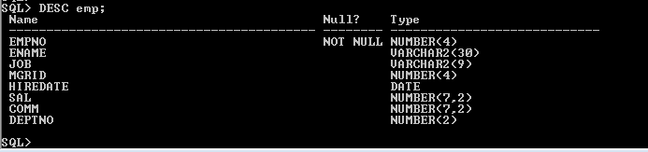

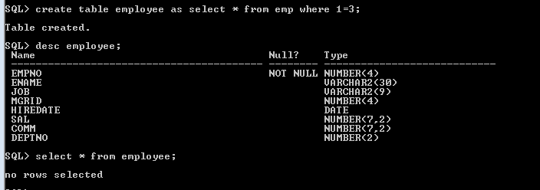

1. Write a query to populate Employee table using EMP table’s empno, ename, sal, deptno columns.

SQL>select * from employee

|  |  |  |  |  |  |  |  |
| --- | --- | --- | --- | --- | --- | --- | --- |
| **EMPNO** | **ENAME** | **JOB** | **MGR** | **HIREDATE** | **SAL** | **COMM** | **DEPTNO** |
| 7369 | SMITH |  |  |  | 800 |  | 20 |
| 7499 | ALLEN |  |  |  | 1600 |  | 30 |
| 7521 | WARD |  |  |  | 1250 |  | 30 |
| 7566 | JONES |  |  |  | 2975 |  | 20 |
| 7654 | MARTIN |  |  |  | 1250 |  | 30 |
| 7698 | BLAKE |  |  |  | 2850 |  | 30 |
| 7782 | CLARK |  |  |  | 2450 |  | 10 |
| 7788 | SCOTT |  |  |  | 3000 |  | 20 |
| 7839 | KING |  |  |  | 5000 |  | 10 |
| 7844 | TURNER |  |  |  | 1500 |  | 30 |
| 7876 | ADAMS |  |  |  | 1100 |  | 20 |
| 7900 | JAMES |  |  |  | 950 |  | 30 |
| 7902 | FORD |  |  |  | 3000 |  | 20 |
| 7934 | MILLER |  |  |  | 1300 |  | 10 |

14 rows selected.

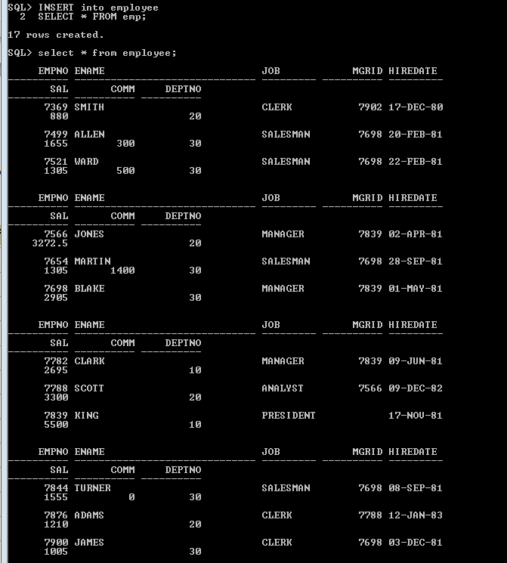

1. Write a query to change the job and deptno of employee whose empno is 7698 to the job and deptno of employee having empno 7788.

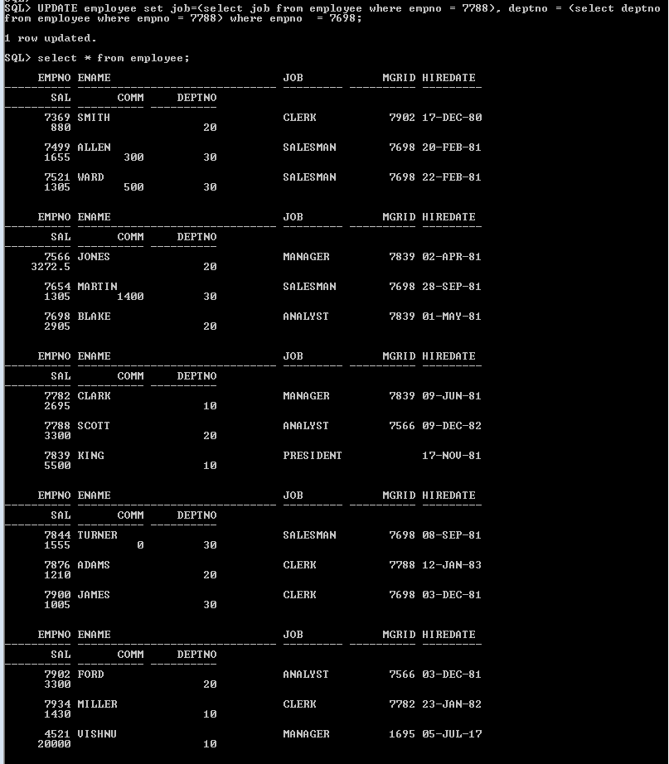

1. Delete the details of department whose department name is ‘SALES’.



1. Write a query to change the deptno of employee with empno 7788 to that of employee having empno 7698.



1. Insert the following rows to the Employee table through parameter substitution.

* 1000,Allen, Clerk,1001,12-jan-01, 3000, 2,10
* 1001,George, analyst, null, 08 Sep 92, 5000,0, 10
* 1002, Becker, Manager, 1000, 4 Nov 92, 2800,4, 20
* 1003, 'Bill', Clerk, 1002, 4 Nov 92,3000, 0, 20

